Phys 511: Assignment Papers: **Neutron Lifetime**

Two methods to determine the fundamental neutron lifetime differ by 4 . This is a problem as we can explore, and it nicely introduces us to the concepts of Blind Analyses, and a discussion of Systematic Uncertainties, a theme throughout the course. We will also want to think about, well, what might lead to a “longer than actual” lifetime vs. a “shorter than actual” lifetime. Hmmm, which technique is right? For those interested, there is a paper, using a broader consideration of various coupled physics effects, that makes a clear choice … but then again, that choice assumes the SM is right. Again, “hmmm”.

1) Pattie et al. uses the latest in the “bottle” methods, with a “magneto-gravitational” trap of ultra-cold neutrons (UCNs). Right off, the UCN production might also be worth a discussion. At least look up what they are and how slow they go … okay, a few m/s.

2) Yue et al, is the latest update in an ongoing effort using a cold beam of neutrons passing through a solenoid. This experiment continues and is running now with some improvements. They are also proposing a bigger one, but entirely along the same lines. What are they doing and why do they like this approach?

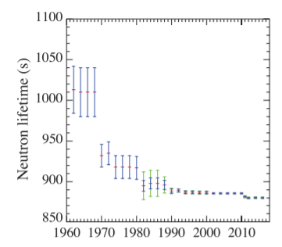The history of the neutron lifetime vs time is a famous plot: We will be concerned with only the latest data (too small to see here), but you can spot them here in this other way of looking. The blue bands correspond to different neutron lifetimes. Intrigued yet?